LAB4_4

setwd(".")  
library(knitr)  
library(ggplot2)  
library(mgcv)

## Loading required package: nlme

## This is mgcv 1.8-28. For overview type 'help("mgcv-package")'.

empleo<-read.csv("Archivos/Empleos_Informatica_Canarias_2009-18.csv", sep=";")  
attach(empleo)

#APARTADO A

#------------CAN 62------------#  
CAN_62<-empleo[TRIMESTRES=="CNAE_62",2]  
index<-seq(length(CAN_62),1,-1)  
CAN_62_t<-CAN_62[index]  
  
plot(1:length(CAN_62_t), CAN_62_t, xaxt="n", type="l",  
 xlab="Año", ylab="Personas Empladas CNAE:62",  
 ylim = c(0,max(CAN_62_t)),col="red", lwd=2)  
years<-c("2009","2010","2011","2012","2013","2014","2015",  
 "2016","2017","2018")  
axis(side=1, at = seq(1,length(CAN_62),4),   
 labels = years)  
grid()  
  
#GRAFICAS DE EMPLEO PARA GC Y TF  
TFE_62<-TENERIFE[TRIMESTRES=="CNAE_62"]  
GCA_62<-GRAN.CANARIA[TRIMESTRES=="CNAE_62"]  
  
#PUNTOS PARA CADA UNA DE LAS ANTERIORES  
points(1:length(CAN_62),TFE_62[index], type="l", col="blue",lwd=2)  
points(1:length(CAN_62),GCA_62[index], type="l", col="yellow",lwd=2)

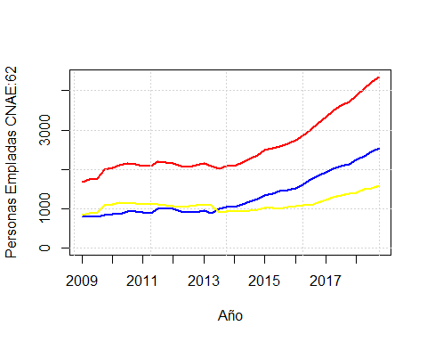

#------------CAN 63------------#  
CAN_63<-empleo[TRIMESTRES=="CNAE_63",2]  
index<-seq(length(CAN_63),1,-1)  
CAN_63_t<-CAN_63[index]  
  
plot(1:length(CAN_63_t), CAN_63_t, xaxt="n", type="l",  
 xlab="Año", ylab="Personas Empladas CNAE:63",  
 ylim = c(0,max(CAN_63_t)),col="red", lwd=2)  
years<-c("2009","2010","2011","2012","2013","2014","2015",  
 "2016","2017","2018")  
axis(side=1, at = seq(1,length(CAN_63),4),   
 labels = years)  
grid()  
  
#GRAFICAS DE EMPLEO PARA GC Y TF  
TFE_63<-TENERIFE[TRIMESTRES=="CNAE_63"]  
GCA_63<-GRAN.CANARIA[TRIMESTRES=="CNAE_63"]  
  
#PUNTOS PARA CADA UNA DE LAS ANTERIORES  
points(1:length(CAN_63),TFE_63[index], type="l", col="blue",lwd=2)  
points(1:length(CAN_63),GCA_63[index], type="l", col="yellow",lwd=2)

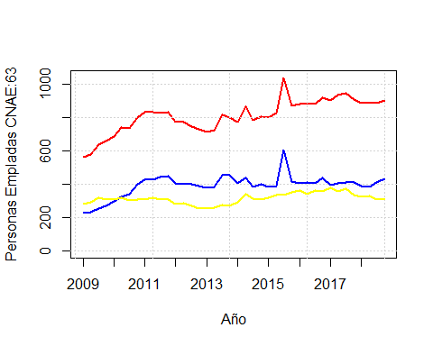

#------------CAN 95------------#  
CAN_95<-empleo[TRIMESTRES=="CNAE_95",2]  
index<-seq(length(CAN_95),1,-1)  
CAN_95_t<-CAN_95[index]  
  
plot(1:length(CAN_95_t), CAN_95_t, xaxt="n", type="l",  
 xlab="Año", ylab="Personas Empladas CNAE:95",  
 ylim = c(0,max(CAN_95_t)),col="red", lwd=2)  
years<-c("2009","2010","2011","2012","2013","2014","2015",  
 "2016","2017","2018")  
axis(side=1, at = seq(1,length(CAN_95),4),   
 labels = years)  
grid()  
  
#GRAFICAS DE EMPLEO PARA GC Y TF  
TFE_95<-TENERIFE[TRIMESTRES=="CNAE_95"]  
GCA_95<-GRAN.CANARIA[TRIMESTRES=="CNAE_95"]  
  
#PUNTOS PARA CADA UNA DE LAS ANTERIORES  
points(1:length(CAN_95),TFE_95[index], type="l", col="blue",lwd=2)  
points(1:length(CAN_95),GCA_95[index], type="l", col="yellow",lwd=2)

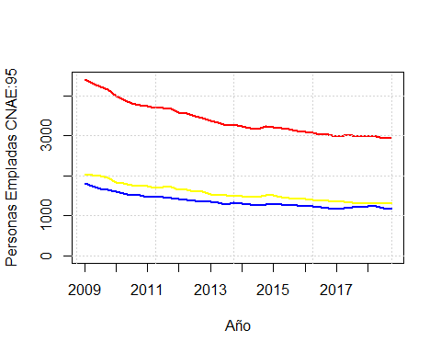

#APARTADO B

#Hecho para el CAN62.  
  
#----------------- Grafica inicial -----------------#  
y63<-CAN_63_t  
x63<-seq(1,40)  
y62<-CAN_62_t  
x62<-seq(1,40)  
y95<-CAN_95_t  
x95<-seq(1,40)  
  
plot(x63,y63, xlim=c(1,52), ylim=c(min(y63),2.5*max(y62)),  
 xlab="Predicción Empleo", ylab ="Numero de puestos", col="red", type="l", lwd=2)  
points(x62,y62, type="l", col="orange", lwd=2)  
points(x95,y95, type="l", col="blue", lwd=2)  
  
  
#-----------------CAN 62-----------------#  
x<-x62  
y<-y62  
modelogam62<-gam(y~s(x))  
xv62<-(40:52)  
yv62<-predict(modelogam62, list(x=xv62))  
points(xv62,yv62, type="l", col="brown", lwd=2)  
  
  
#-----------------CAN 63-----------------#  
x<-x63  
y<-y63  
modelogam63<-gam(y~s(x))  
xv63<-(40:52)  
yv63<-predict(modelogam63,list(x=xv63))  
points(xv63,yv63, type="l", col="pink", lwd=2)  
  
  
#-----------------CAN 95-----------------#  
x<-x95  
y<-y95  
modelogam95<-gam(y~s(x))  
xv95<-(40:52)  
yv95<-predict(modelogam95,list(x=xv95))  
points(xv95,yv95, type="l", col="lightblue", lwd=2)  
  
#-----------------FINAL -----------------#  
  
abline(v=40, col="black", lwd=2, lty=2)  
grid()

